**Report “Lab 1”**

**Anton Tserakhau**

# Data Warehouse Architecture – Storage Layers

I have created Storage Objects and generated Test Data in Storage Layers.

1. I have created tablespace for temporary tables.
2. I have created external table T_EXT_DISHES, mapped data into temporary table TEMP_DISHES. I have inserted data from temporary table TEMP_DISHES into table CLS_DISHES.

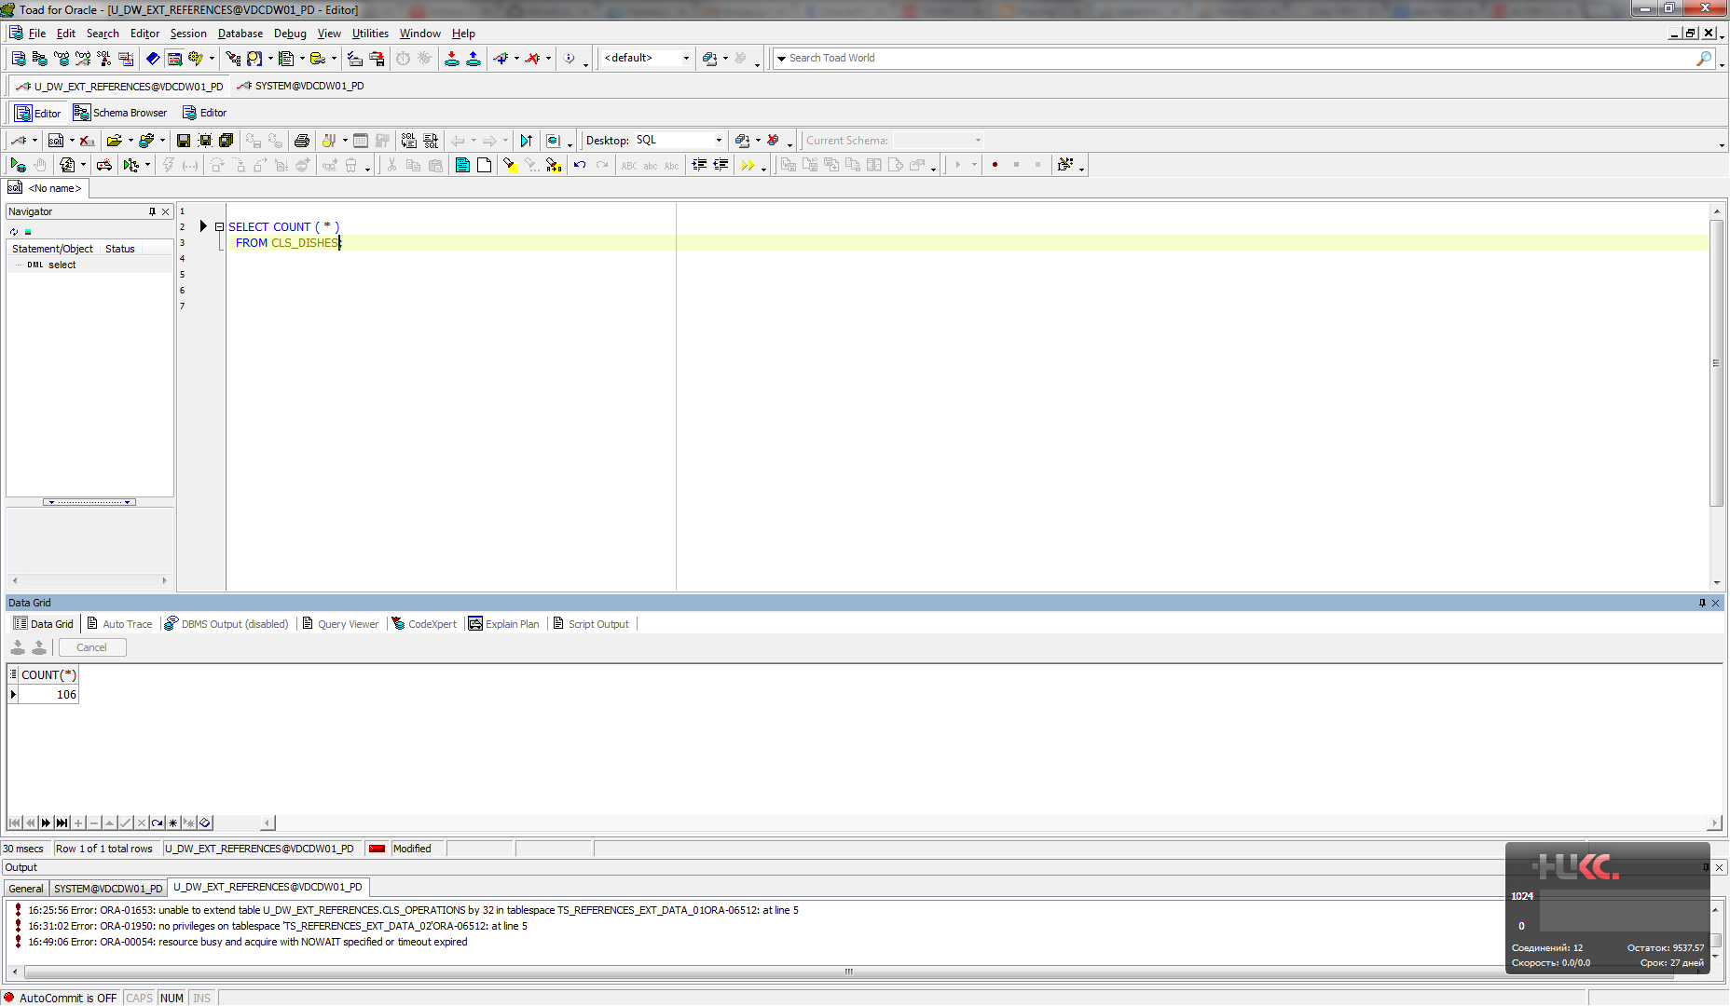

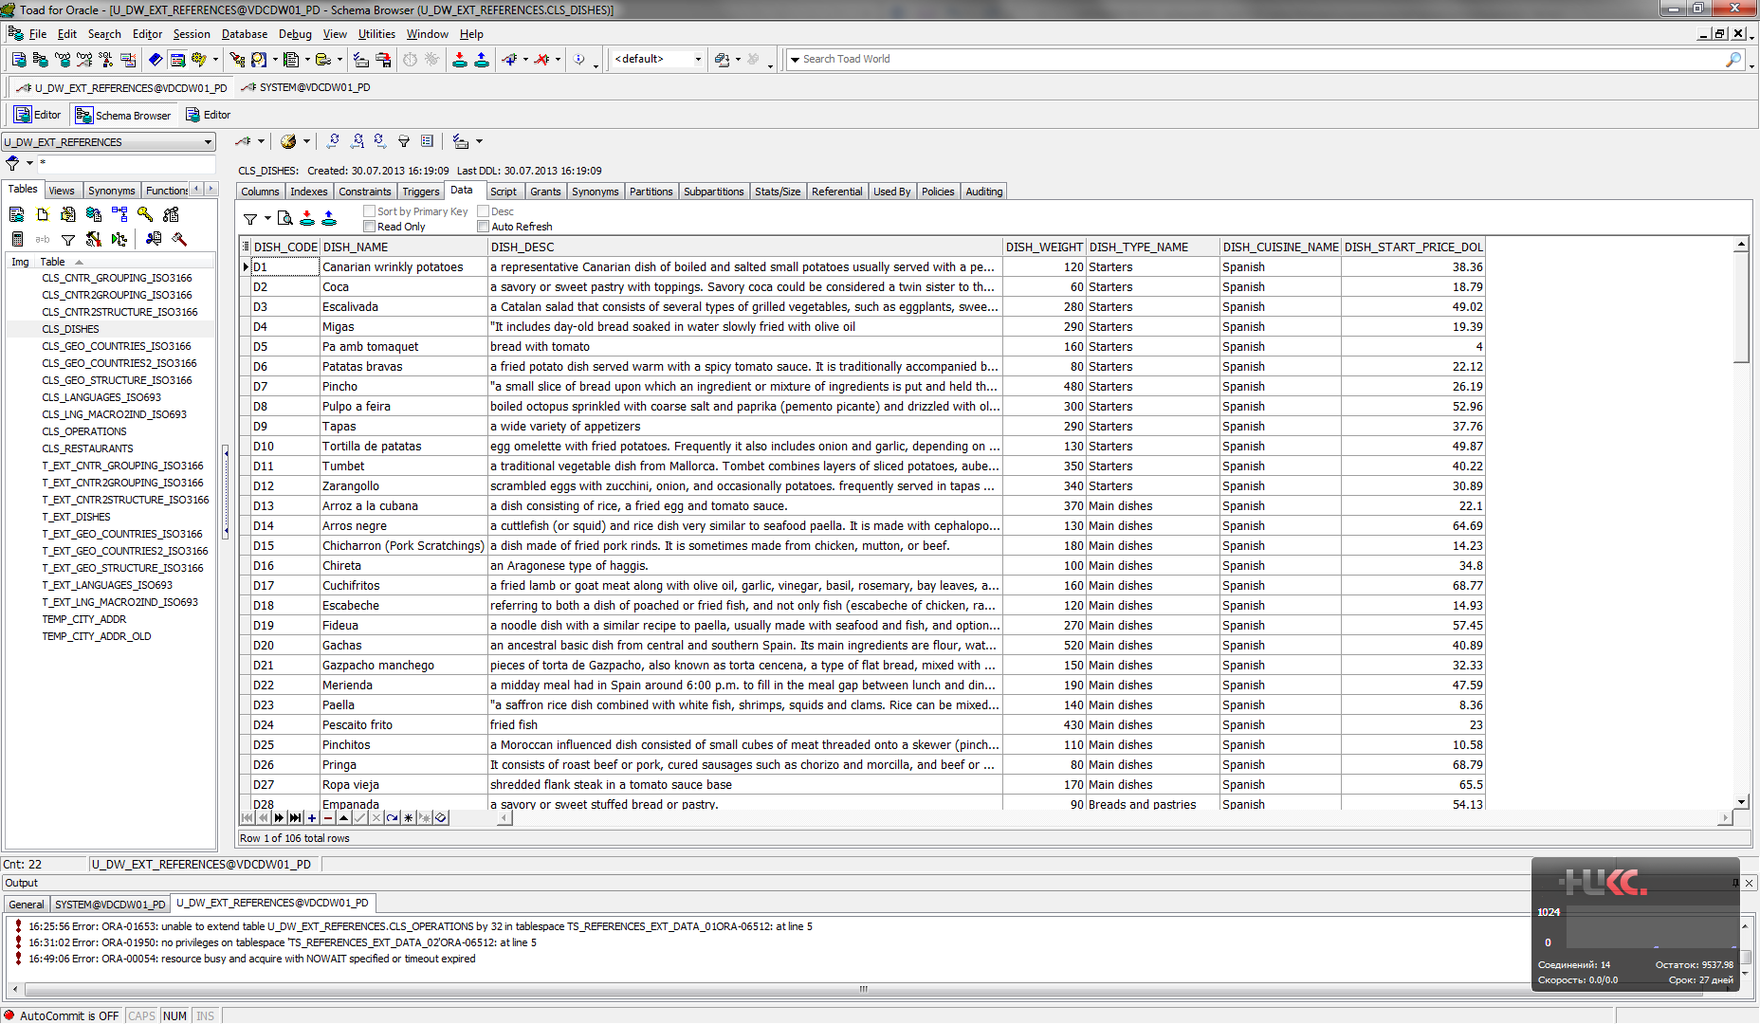

1. I have created script on SH scheme with test data:

Select distinct rownum numb,

cust.cust_street_address,

cust.cust_postal_code,

cust.cust_city,

cust.cust_city_id,

cust.cust_state_province,

cust.cust_state_province_id,

cnt.country_id,

cnt.country_iso_code,

cnt.country_name

from customers cust

left join countries cnt

on cust.country_id = cnt.country_id;

1. I have created temporary table TEMP_CITY_ADDR and inserted test data. I have inserted data from temporary table TEMP_CITY_ADDR into table CLS_RESTAURANTS.

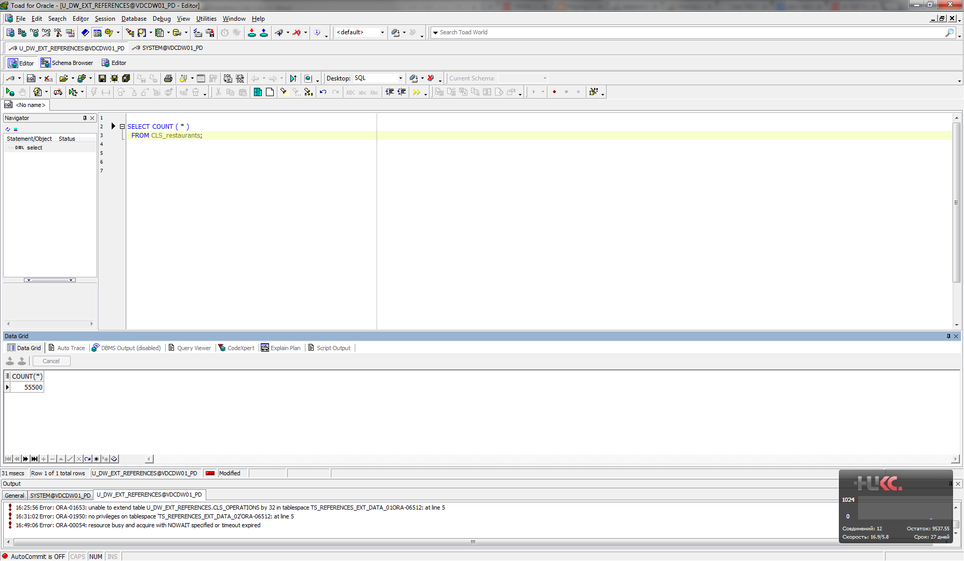

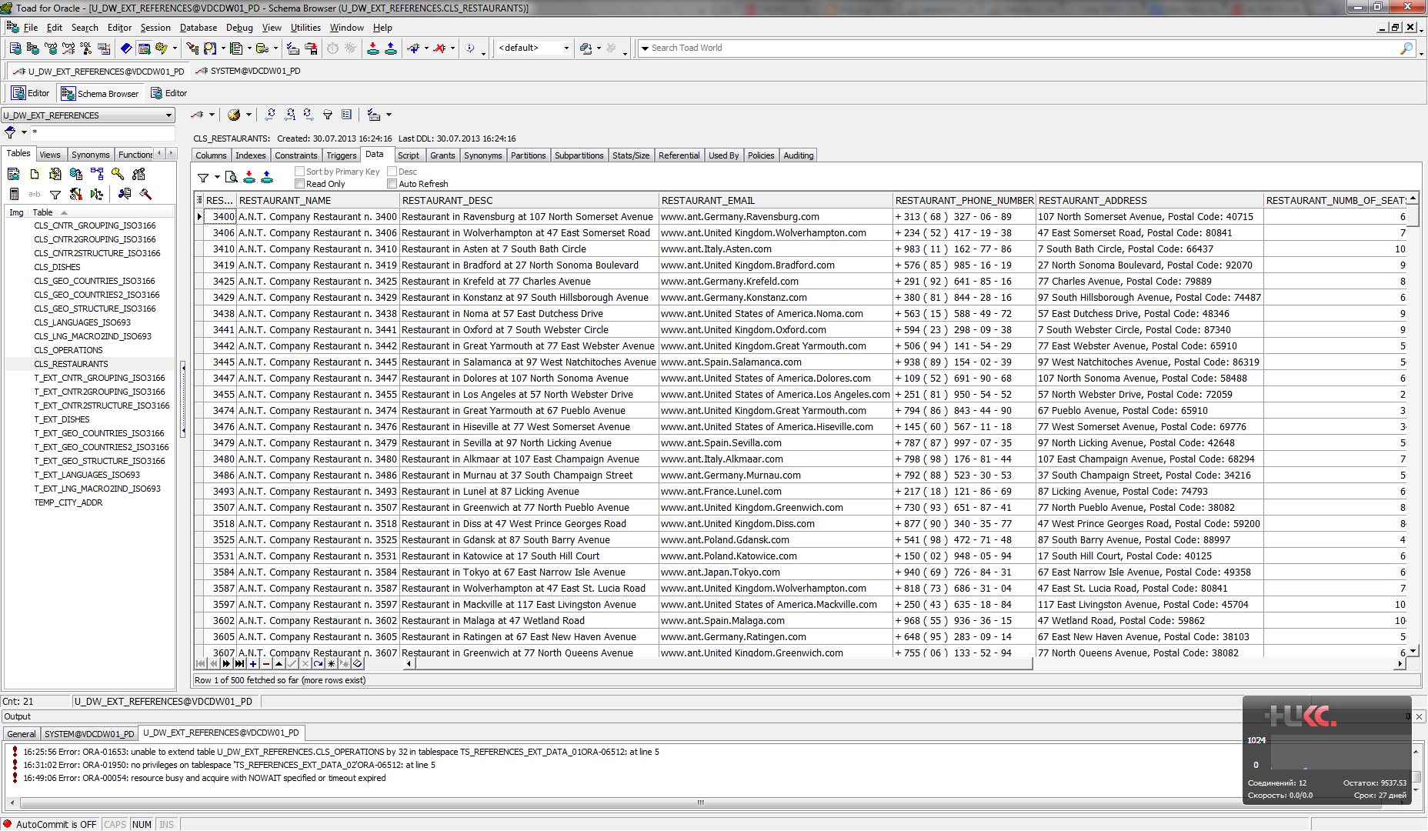

1. I have created table CLS_OPERATIONS and generated data from all previous tables.

